# Introduction

This walkthrough has been written to accompany the English fan-translation patch of the game, created by Envy, Illidan & Phantom.

It covers the basics of progression including maps and boss guides, but does not include side content like the Extra/Special Lessons available from chapter 5 which are fairly self-explanatory. If needed, you can refer to the “data collection” on [this site](http://musekinindou.web.fc2.com/souleater/ds/index.html) (JPN) for more info.

## A note on Emulation

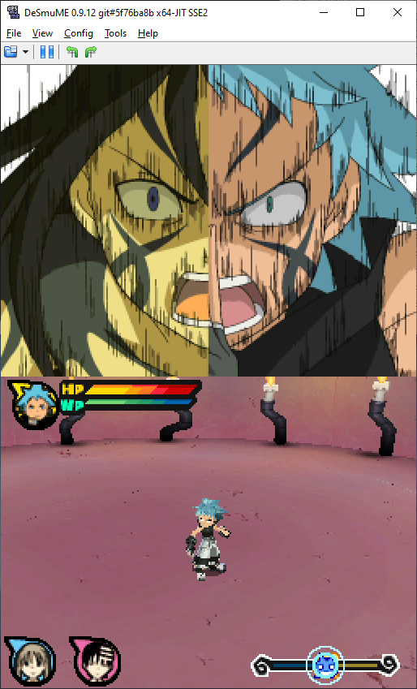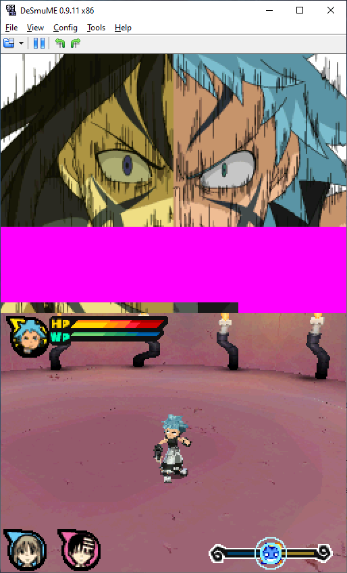If playing this game on an emulator, you may notice an issue where certain images are obstructed by a solid pink color. This is purely an emulator bug which happens even when emulating the un-patched game, but does not happen on real hardware. We recommend updating to the latest build of DeSmuME, which can be found [here](https://ci.appveyor.com/project/zeromus/desmume/build/artifacts).

On DeSmuME 0.9.12

On DeSmuME 0.9.11

# Chapters 1-3

The first three chapters cover a tutorial with each character’s individual move set. For the most part, you’ll have unlimited HP & WP until reaching the boss stage (if there is one.) It’s a nice opportunity to get used to the game’s combat system without having to worry too much.

## Chapter 1

[Death City]

A tutorial featuring Maka & Soul. There’s no boss.

## Chapter 2

[Cinder Castle]

A tutorial featuring Black☆Star & Tsubaki. At the end of this chapter, you’ll face your first real fight; Mifune.

### Mifune:

Each boss has different attack styles depending on their HP.

|  |  |  |
| --- | --- | --- |
| **[First stage]** | | |
|  |  |  |
| Mifune will peform lunge attacks in sets of 3. After a set, he will fall to the ground which is the best time to strike. | | |
| **[Second stage]** | | |
|  |  |  |
| In the second stage, Mifune changes to his “Infinite One-Sword Style”, in which he throws his swords into the air, then pulls out one of the fallen swords to strike with.  Wait for him to complete the attack, then use that opportunity to counter-strike. | | |
| **[Third stage]** | | |
|  |  |  |
| When his HP is 2 or below, Mifune will switch to a ranged attack, sending out shockwaves with his sword. This is a strong attack but it can only travel in straight lines, so is easy to avoid.  After sending out a shockwave he will fall to the ground defenseless, which you can use to finish him off. | | |

## Chapter 3

[Ancient Ruins]

A tutorial featuring Kid & the Thompson Sisters. At the end of this chapter is another boss.

### Pharaoh:

|  |  |  |
| --- | --- | --- |
| **[First stage]** | | |
|  |  |  |
| When you are away from the casket, it will open and attack. After the attack, strike before the lid closes again. | | |
| **[Second stage]** | | |
|  |  |  |
| Once his health is 4 or below, Anubis will emerge. He will try grab Kid with his bandages to pull you closer and attack. Keep your distance and fire out Continuous Shots (by drawing a 十) to send him back to the afterlife. | | |

# Chapter 4

[Hook Cemetery]

There’s a mini-tutorial about changing character modes before we’re back into our next boss.

### Sid:

|  |  |  |
| --- | --- | --- |
| **[First stage]** | | |
|  |  |  |
| During the first stage, Sid will swing his grave at you. There’s an opening after each attack, so use that chance to counter. | | |
| **[Second stage]** | | |
|  |  |  |
| Next, Sid will perform his “Living End” attack (slamming his gravestone from above) in sets of 3. You can either dodge and attack from behind, or wait until he drops the stone at the end of a set for an opening. | | |
| **[Third stage]** | | |
|  |  |  |
| During this stage Sid will disappear underground, then pop up to attack. He can’t be hit when underground, so wait until he re-appears to strike. | | |

## [Death City]

Hit switch 1 to remove the first set of flames.

Go to the left of the crossroads, break the wooden boxes using Maka and then continue down.

After defeating all of the enemies, hit the switch that appears. (Flame 2 disappears.)

Head back to the crossroad then down, and annihilate the enemies in the square to remove the flames.

Cross the river with Kid's skateboard.

Defeat the Mice, and switch 3 will appear. (Removes flame 3. A healing spring will also appear so you can regain HP before heading to the next boss.)

### Stein:

|  |  |  |
| --- | --- | --- |
| **[First stage]** | | |
|  |  |  |
| In the first stage, Stein will attack while sitting on his chair. Stop his movements with the Black☆Star’s “Chain Scythe Throw” (draw a circle), then quickly deal damage whilst he is still spinning.  If you’re struggling to catch Stein, use Kid to fire at and temporarily stop him before switching to Black☆Star. | | |
| **[Second stage]** | | |
|  |  |  |
| In the second stage, Stein performs a rush attack, which will knock you to the floor if hit.  What’s more, is that by matching wavelengths, Stein will be able to nullify your attacks. Watch the colored outline to determine whose attacks will be powerless. (Kid: pink, Black☆Star: yellow, Maka: blue.)  Keep dodging, and wait for an opening where Stein turns the screw on his head. Use this time to close the distance and land your attacks (with any character.) | | |
| **[Third stage]** | | |
|  |  |  |
| The third stage features the same attack pattern, however Stein’s attacks will be stronger. If you want to play it safe, use Black☆Star’s “Chain Scythe Throw” from a distance when the colored outline is not yellow. Else, Maka’s “Strike” is recommended. | | |

# Chapter 5

## Lord Death’s Task: Find Dr. Stein and Professor Sid!

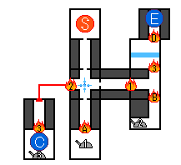Once you have two or more Lord Death Stickers, you can accept this lesson from the Death Room.

Head down, and defeat the Rats to make switch 1 appear. (Flame 1 disappears.)

Return and go left. Switch 2 appears after you’ve wiped out the Red Tadpole Bombs. (Flame 2 disappears & a healing spring appears.)

Find Professor Sid and switch 3 at point C. (Flame 3 disappears.)

Use Kid’s skateboard to cross the water and defeat all the Black & Red Tadpole Bombs. (Flame D disappears.)

Find Dr. Stein at point E.

After completing Lord Death’s Task, new events will unlock in Death City; Cinder Castle, Chupa Cabra's, and the Church.

## [Church]

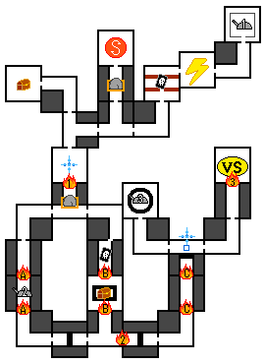Head right and hit switch 1 which appears once the Death Noirs & Candles are destroyed. (Flame 1 disappears & a healing spring appears.)

Next, head left and wipe out the Candles. (Flame A disappears & switch 2 appears.)

Cross the valleys using Kid's skateboard.

Destroy all the Candles and Stone Statues in the long corridor to remove flame C.

Continue forward and use Black☆Star’s “Chain Scythe Throw” on the blue hook to cross the gap.

Hit switch 3, which appears when you clear out the Candles and Stone Statues. (Flame 3 disappears & a healing spring appears.) Then, head up to the next boss.

## Crona:

|  |  |  |
| --- | --- | --- |
| **[First stage]** | | |
|  |  |  |
| Keep dodging until after Crona attacks with their sword, when there’s a good opening. Utilize Maka’s “Slash” as it’s fast but powerful. | | |
| **[Second stage]** | | |
|  |  |  |
| After a short cutscene with Stein, the battle resumes. “Bloody Needle” is hard to dodge, but not all that powerful, so it’s okay if you can’t completely avoid it. | | |
| **[Third stage]** | | |
|  |  |  |
| In the third stage, Crona will start using “Screech Alpha” (sending out a black shockwave), however your tactics can stay the same. Avoid being hit by Screech Alpha which will send you flying, and aim for the gap that opens after Crona swings their sword.  Watch out for a powerful bloody needle that comes after you’ve landed a hit. | | |

# Chapter 6

## Lord Death’s Task: Death City Patrol!

Kill 50 enemies of any type. After completing this lesson, head to the Infirmary to continue with the story.

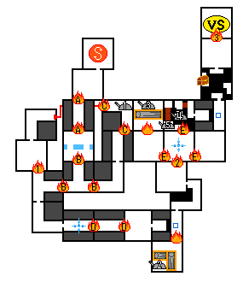[London]

Head down, and wipe out the Mad Dogs and Red Tadpole Bombs. (Flame A disappears.)

Defeat all the Mad Dogs at the crossroads to put out flame B, then head right and up.

Clear out the Mice, and hit switch 1 that appears. (Flame 1 goes out.)

Continue on, and clear out the Mice & Red Tadpole Bombs to remove flame D.

Use Black☆Star’s “Chain Scythe Throw” throw on the blue hook to cross the gap, then head down.

Defeat all the enemies, then use Maka to destroy the fallen columns and hit switch 2. (Flame 2 disappears.)

Head back up and destroy the Mad Dogs. (Flame E disappears & a healing spring appears.)

Go left, clear out the Mice, then use Maka to destroy the fallen columns and hit switch 2. (Flame 2 disappears.) You can then head back and follow the path straight up to the next boss.

## Free:

|  |  |  |
| --- | --- | --- |
| **[First stage]** | | |
|  |  |  |
| During the first stage, Free’s main attacks are physical (short-range) and magic ice pillars (long-range.) Focus your attacks on the opening that appears after his iron ball attack, using combos to shave away at his HP. | | |
| **[Second stage]** | | |
|  |  |  |
| Next, Free throws ice arrows at you from a distance. It’s possible to close the distance by dodging them, but an easier approach is to use Maka to reflect the arrow, then immediately counterattack with Kid who is good at long-distance attacks. | | |
| **[Third stage]** | | |
|  |  |  |
| In the third stage, Free fires his “Magic Eye Cannon” from a distance. It’s powerful, but it can only be fired in a straight line so is easy to dodge. Keep targeting the opening that appears after his iron ball kick. | | |

# Chapter 7

## Lord Death’s Task: Defeat the Witch Mizune!

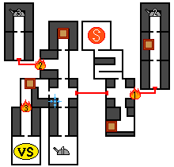[Death City]

Start with switch 1. (Flame 1 disappears.)

Next, flip Switch 2 which appears once you’ve destroyed all the Red Tadpole Bombs & Black Tadpole Bombs. (Flame 2 disappears.)

Switch 3 appears after you’ve wiped out the Bad Eaters. (Flame 3 disappears.)

Finally, defeat all the Mizunes!

After completing this lesson, head to the Assembly Hall to continue with the story. This is the **point of no return**, so if you have remaining points, be sure to visit the Death Room to level up before getting started. (I recommend focusing on Defense and HP/WP.) You will however have another opportunity to save before the finale.

## [Below DWMA]

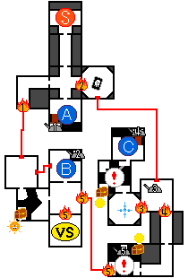Head down, cross the bridge that appears when you kill 6x Bad Eaters at point A, then flip switch 1. (Flame 1 disappears.)

Defeat the Candles at B and hit switch 2. (Flame 2 disappears)

Hit switch 3. (Flame 3 goes out.) *You can switch it without having to jump up by using Maka’s “Slash”.

Head up to point C, defeat the Candles to open the bridge and flip switch 4. (Flame 4 disappears & a healing spring appears.)

[The “!” highlights places where it’s advisable to use Kid’s skateboard to get through.]

Head back down and flip switch 5 to open the way to the boss.

## Free (Second Time):

He has slightly more health, but the moves/opportunities to counter attack remain the same. See chapter 6 for an in-depth guide.

## [Below DWMA 2]

Head left from your starting point using Kid’s skateboard, and continue to the right.

Flip switch 1. (Flame 1 goes out.)

At point A, kill the 8x Bad Eaters, then cross the bridge which appears and hit switch 2. (Fire 2 disappears & a healing spring appears.)

Defeat 8x Death Noir at point B to remove flame B, then head to the next boss.

## Crona (Second Time):

Again, not much has changed from the first encounter. See chapter 6 for an in-depth guide.

Part-way through this fight, a cutscene will play where Maka decides to use the power of the black blood inside Soul to sink into madness. She will be surrounded by a black wavelength and slightly faster, so is a good character to use for this fight.

## Ragnarok:

|  |  |  |
| --- | --- | --- |
| **[First stage]** | | |
|  |  |  |
| During the first stage, Ragnarok will chase you whilst swinging his arms. Keep your distance, and use Kid’s “Continuous Shot” to do damage. | | |
| **[Second stage]** | | |
|  |  |  |
| Next comes a hand-jab attack. If it hits you, you’ll be thrown to the ground. Aim to strike after this attack, using one of Black☆Star’s combos or Maka’s “Strike”. Watch out for a violent counter after you land a hit.  Once Ragnarok starts using “Bloody Needle”, you can interrupt his attacks by striking first. | | |
| **[Third stage]** | | |
|  |  |  |
| From here, Ragnarok will screech before slamming his hands on the ground producing a huge shockwave, which can hit you even from behind. Keep your distance, and aim for the gap between attacks when he’s catching his breath, doing damage with Maka’s “Full Sweep”. | | |

After this battle, you’ll have an opportunity to save the game before being thrown straight back into the action.

## [Below DWMA 3]

Use Kid’s skateboard to reach switch 1. (Flame 1 goes out.)

Head to point A, wipe out the Bad Eaters then   
cross the bridge where switch 2 will appear. *(A treasure chest containing a full health restore also appears.)*

Defeat the Candles at point B, cross the bridge and flip switch 3. (Flame 3 disappears.)

Continue to switch 4. (Flame 4 goes out & a healing spring appears.)

Defeat the Bad Eaters at C, cross the bridge, and turn on switch 5.  (Flame 5 goes out.)

Again, at point D, wipe out the Bad Eaters,    
cross the bridge that appears and use switch 6. (Flame 6 goes out.)

Defeat the 9x Death Noir at E. (Flame E disappears.)

## Medusa:

The final boss!

|  |  |  |
| --- | --- | --- |
| **[First stage]** | | |
|  |  |  |
| After an incantation, several mid-range vector arrows will spring from Medusa’s back. Use the time whilst she’s casting to land your attacks and shave down her HP. | | |
| **[Second stage]** | | |
|  |  |  |
| After a cutscene, Medusa will start using her Vector Plates. They’re hard to avoid, so watch your step and use attacks with large scopes such as Maka’s “Slash” & “Full Sweep”.  If you get caught by a plate, Medusa will likely be launching herself at you from the other direction, so try to move sideways to dodge. | | |
| **[Third stage]** | | |
|  |  |  |
| After this, Medusa’s Vector Arrows will be able to reach you even from a long distance. The arrows appear once she’s finished her incantation, so disrupt the chanting using Kid. If you keep attacking like this, you can slowly but surely build damage until you’re able to perform Soul Resonance and use the Death Cannon to shave off a full square. (Or, if you have HP to spare, you can aim for the moment the Vector Arrows appear using Maka’s “Strike” to finish things quicker.) | | |

# Closing

Congratulations, you’ve cleared the game! You’ll be given the opportunity to save your clear data, which you can use to play from the start. There’s no New Game + benefits, but Blair (cat form) will join you by following Maka around! (She disappears when enemies’ attack.)

## Credits:

English translation patch by the Anime Game Translations Team.

Translation: [Envy](https://www.youtube.com/channel/UCLlA94ADa7AHxWEaVGnhEBw)

Hacking: [Illidan](https://gbatemp.net/members/illidanz.334557/)

Graphics: [Phantom](https://phantom-patches.tumblr.com/)

Information/images for the walkthrough translated from [Musekinindou](http://musekinindou.web.fc2.com/souleater/ds/index.html) and [GameWatch](https://game.watch.impress.co.jp/docs/20081020/se.htm), alongside own research.

Questions, comments or typos? Shoot me a message at phantomghosttranslations(@)gmail.com

Hope you enjoyed!